**Work In Progress**

**FreshChoice**

**Group 3**

Team Member:

Kritica Shakya

Ritik Khadgi

Bishwa Thakuri

Pritishma Pradhanang

Sudip Shrestha

Table of Content

1. **Initiation phase**
2. **Project Charter**

* Version Control
* Project Justification
* Project Scope
* Project Assumption
* Roles & Responsibilities

1. **Team Contract**
2. **Meeting Minutes**
3. **Planning phase**
4. **Belbin Analysis**

* Team Belbin’s Analysis
* Individual Belbin’s Analysis

1. **Skills Audit**

* Team Skills Audit
* Individual Skills Audit

1. **Project Management**

* Gantt Chart
* Network Diagram
* Timeline
* Calendar
* Resource Sheet
* Change Working Time

1. **Communication Tool Used**
2. **Execution phase**
3. **Entity Relationship Diagram**

* EERD
* ERD
* Final composite ERD
* Logical Table

1. **Use Case Table**

* Overview Use Case Diagram
* Customer Use Case Diagram
* Trader Use Case Diagram
* Admin Use Case Diagram

1. **Requirement Catalogue**

* Functional Requirement
* Non-Functional Requirement

1. **Logo Design**
2. **Wireframe**

* Website Homepage
* Website Aboutpage
* Website Contactpage
* Admin CRUD
* Trader CRUD
* Cart
* Customer Register
* Trader Register
* Customer Profile
* Dashboard
* Invoice
* Login
* Product detail/Review
* Shop

1. **Product development**

* Website Aboutpage
* Website Contactpage
* Customer Register
* Trader Register
* Login

1. **Initiation Phase**
2. **Project Charter**

|  |
| --- |
| Project Title: FreshChoice  Project Manager: Rohit Pandey  Sponsor: The British College  Customer: Local People |

**Version Control**

|  |  |  |
| --- | --- | --- |
| Version | Date | Summary of changes |
| 1 | 05/02/2021 | *Initial Project Plan (1st draft changes made if necessary or requirement needed)* |
|  |  |  |

**Project Justification**

|  |
| --- |
| This project is mainly focused on providing daily services to the local people of CleckHuddersFax and developing the small independent business through online portal. The main target of this project is to provide quality services to our customer along with keeping the value of time, money and food availability in mind. Providing a one-stop store for groceries along with a list of traders and with their varieties of food items.  Due to the increase in national chains and with the proposal for larger stores, the traders aware of this situation have decided to come along with an idea of offering a joint e-commerce portal to their shops. By using e-commerce portal, the local business can reach to a larger group of customers. This portal will help the traders to add their products and sell them on one-click basis. With this system having a flexible timeslot it helps the local traders in balancing their work life and family life. Another benefit of this portal is that the traders can get a monthly report of product sales and weekly finance report.  Traders can also check the daily basis analysis on their orders and stock levels. With the help of the reports, the traders can also analyse the market potential i.e. they will have a clear idea of the demand of their products and on that basis they can arrange the stocks. With an e-commerce site that allows the traders to collect information about their customers behaviour, taste and ongoing trends so that the traders can manage products and services accordingly and attract more customers along with exclusive offers and discounts. All these data that are collected will help the traders to strategize their marketing policies.  Considering the time contrast between the opening of local stores and business hours, the e-commerce site allows 24/7 availability of products to the customers. The customer experiences a wide variety and range of products with offers and good discounts. Talking about the essence of time, it will help the customers to save time as well as order any essential goods from the comfort of their home while doing their other task and can collect when they are free. Customers can get a detailed information on the quality of the products. Online e-commerce also provides the features to track order status and collection slots status.  As the portal will try to emphasis on encapsulating the heritage of the local area, it will give a homely sense to the customers while browsing through the site which will help both the traders and customers as it can give a sense of assurance and trust. This portal comes with an easy navigation system which will help consumers of every age group to use it with ease. Another benefit of using an online site, one could easily avoid the bustling crowds during the peak hours, weekends, festivals or any occasions. Also one of the best thing about this online purchase is customers don’t end up buying thing they don’t really need based on the shopkeepers pressure or selling skills.  Taking all of this into consideration, businesses must always be striving to create a better platform for customer based on their needs and trends. In order to do that the e-commerce will boost the business for the trader as well as will help to provide quality service to the customers with various features. Customers can save their time while buying local products as they do not need to be visiting every vendor for particular products and goods. Trader’s having experience with wider target customers on the sites can focus on maximum sales with trader’s profit and effort, also saving their time.  So, initially this FreshChoice e-commerce is established as joint one-stop shop for the customer with different traders and their varieties of fresh quality of local foods which are easily accessible. This e-commerce has opened opportunities to the local stores of CleckHuddersFax and helped the traders to compete with the national chain. The traders are also provided with daily, monthly reports with transactions which saves time and money. E-commerce is continuously growing as an important factor for the businesses with advanced technologies and features coming up steadily which is something that should be taken advantage of and implemented. At the end, it will be a win-win situation for both the customers and the traders with endless possibilities. |

**Project Scope**

|  |
| --- |
| *The objectives should be SMART:*  *S – Specific*  A foodhub site having different products line from various local stores of CleckHuddersFax which is easy to access and also provide reports to the traders.  Focusing on encapsulating the heritage of local area as well as to balance their worklife.  *M – Measureable*  Completing step-by-step procedure every week.  Will be achieved within 9-10 weeks of timeslot.  *A – Achievable*  Creating a user-friendly site which is easy to navigate.  To provide more opportunities to engage trader and customer closer.  *R – Relevant*  Updating the sites based upon the current demand and situation.  Focused on how the traders can attract more customers and increase their sales.  *T – Time Bound*  Start date – May 2nd End date – July 2nd  Division of workload for the completion of the work on time. |
| **Customer Interface**   1. Initial pilot project with 5 traders with 10 shops and with an option to add later on 2. Navigation control of products by shop or product type. 3. Dynamic and adaptive interface while encapsulating the heritage of the area as far as possible. 4. Login and registration system which should be connected through emails to create an account which can also be updated if required and customer should be logged in order to buy any products. 5. Providing a basket where a customer could add all product and includes its total amount to pay which will be reported back to traders after breakdown of goods ordered and payment received. 6. Selective slot system from where customers can collect their goods where each slot can hold max of only 20 items. 7. PayPal as an online payment.   **Traders Interface**   1. A separate login page for the trader through which they can perform CRUD operation on item based on there unique id. 2. A separate dashboard for trader where they can update there information and generate there daily report like order and stock level.   **Management Interface**   1. A management admin login to dashboard with all daily and periodic reports along with access to the trader's account and reports. 2. Daily reports on order of goods with delivery slots and proper labelling with product details. 3. A weekly finance report which will identify payments to be made of orders that have been delivered. 4. A monthly report on their product sales which can be viewed in a number of ways. |

**Duration**

|  |
| --- |
| Project started in May 2nd and will be ending 2nd July  May 2: Overall review of the case study.  May 9: Belbin analysis and work division.  June 7: Work in progress.  July 2: Final project submission, Project report. |

**Estimated Budget**

|  |
| --- |
| Hours per day per person 4 hours  Hours of week per person 20 hours  Team of 5  Total hours per person 20*10=200 hours  Total hours for final completion by team: 20*5*10=1000 hours |

**Roles and Responsibilities**

|  |  |
| --- | --- |
| Name | Role |
| Kritica Shakya | Primary: Co-ordinator secondary: Implementer least: Monitor evaluation |
| Ritik Khadgi | Primary: Plant secondary: Resource investigator least: Implementer |
| Bishwa Thakuri | Primary: Specialist secondary: Teamworker least: Shaper |
| Sudip Shrestha | Primary: Teamworker secondary: Specialist least: Implementer |
| Pritishma Pradhanang | Primary: Implementer secondary: Teamworker least: Monitor Evaluator |

1. **Team Contract**

Team Contract

The group contract’s intention is to promote academic integrity among the group members. It holds all the details regarding the team structure, procedures, participation, expectations, commitments, and the consequences for breaching the contract which will be followed throughout the project. As it is created in an agreement of all the team members, every member of the team will be held accountable for their actions. The team strictly agrees on the consent and the agreement done by the team members.

Project Team Name: FreshChoice

|  |  |  |  |
| --- | --- | --- | --- |
|  | Team Member Name | Email | Phone |
| 1 | Kritica Shakya | kriticashk@gmail.com | 9808906684 |
| 2 | Ritik Khadgi | hritikkaneki@gmail.com | 9860334224 |
| 3 | Bishwa Thakuri | special1320.bishwa@gmail.com | 9805779089 |
| 4 | Sudip Shrestha | sudipshrestha701@gmail.com | 9851103829 |
| 5 | Pritishma Pradhanang | pradhanang61@gmail.com | 9861988956 |

A. Team Structure:

1. Leadership structure:

Individual leadership will be followed throughout this project.

Kritica Shakya will be leading the team.

1. Decision-making policy:

Our first priority for decision-making would be by consensus.

In case of any disagreement, the decision will be handled by majority of votes.

1. Who is the team Recorder/Documentation Manager/Maintainer of team activity?

Pritishma Pradhanang will be our team recorder who will be saving screenshots of our meetings and any other recordings regarding the project.

Ritik Khadgi and Bishwa Thakuri will be our team’s documentation manager and will be handling all the documentation part of the project.

As the co-ordinator, Kritica Shakya will be the maintainer of the team activity and will be supervising and maintaining all the team schedules and tasks.

1. Day, time, and place for regular team meetings:

Regular timing for meeting: 12 PM – 4 PM

Place for team meeting: Online (discord)

Days for team meet: Sunday - Thursday

1. Usual method of communication:

Discord

Discord Link:<https://discord.gg/TeMKmAQyx6>

B. Team Procedures:

1. Method for setting and following meeting agendas:
   * Every member of the team is free to bring up different ideas for the agenda during the team meeting.
   * All the agendas will be posted in our discord channel which will be pinned as a reminder so that it could be further discussed during the meetings.
   * Every meeting will be started by discussing the ideas regarding the agendas in hand so that no agendas will be missed out.

1. Method of record keeping:
   * Pritishma Pradhanang will be responsible for recording our team meeting screenshots and time slots along with the project schedule.
   * The recordings will be disseminated through discord for all the team members after the team meeting has ended.
   * Each member will have a copy of all the agendas and actions and GitHub will be used as storage for back-up file.

1. Procedures in the absence of a team member:
   * During the absence of one member of the team, the team meeting will be continued, and all the important discussed matter will be pinned on the discord channel with a short briefing in the follow-up meeting.
   * In absence of two or more members the meeting will be further postponed with the discussion for the time of next team meet.
   * The absent members will need to notify the team beforehand with a valid reason.
   * In case of number of absentees without any prior notice or valid reason he/she will be required to respond to PM along with team members.

C. Team Participation:

1. Strategies to ensure cooperation and equal distribution of tasks:
   * Tasks and work responsibilities will be managed by team members and distributed as convenient on the basis of team roles.
   * Each team member will be given certain tasks and will also be assisting other team members in their tasks so that each member can share the workload.

1. Strategies for encouraging/including ideas from all team members:
   * For equal participation team members are encouraged for open discussions and raise questions on the given ideas.
   * Providing feedbacks on ideas and opinions about the agendas and projects.

1. Strategies for keeping on task:
   * Planning a strict schedule and deadlines in each tasks.
   * Following the project and team policies for a stable work environment.
   * Team leader ensures task maintenance of the team.

D. Personal Accountability:

1. Expected individual attendance, punctuality, and participation at all team meetings:
   * All members are expected to attend the team meetings regularly except in case of any emergencies.
   * It is mandatory to attend the meet by 12:10 PM. The attendance should not be less than 72%.

1. Expected level of responsibility for fulfilling team assignments, timelines, and deadlines:
   * The project/tasks should be met before the deadlines and timelines.
   * In unexpected situations, it must be conveyed to the team leader and members so that the team can discuss and complete it as soon as possible. However, it is expected all the deadline will meet.

1. Expected level of communication with other team members:
   * Each team member will have open communication in all team meetings and can easily voice their opinions.
   * All members are requested to be active on discord, Gmail or through phone calls.

1. Expected level of commitment to team decisions and tasks:
   * Any decision or task agreed for the project should followed by all the members in the team.
   * All the team members will fulfil the timeslots divided for the tasks and add more time if needed.
   * All the members are expected to their best on all the tasks given for the project and perform it wholeheartedly.

1. Consequences of breach of contract:

The seriousness of the breach of contract affects the consequences.

* + Low commitment and negligence in the task performed will result in low marks which will be evaluated by the team members.
  + The team will be evaluating minor issues on the basis of skill auditing and quality of the work.
  + If he/she fails to attend the team meeting and deadlines for more than 3 times without a valid reason and does not answer the call then his/her expulsion from the team will be discussed with the project manager.

1. Certification by team members:

In appending your signatures below, you are stating that:

1. You participated in formulating the standards, roles, and procedures of this contract;
2. You have agreed to abide by these terms and conditions of this contract;
3. You understand that you will be subject to the consequences specified above and may be subject to reduction in overall grade in the event that you do not fulfil the terms of this contract.

|  |  |  |  |
| --- | --- | --- | --- |
| Name | Kritica Shakya |  |  |
| Signature |  | Date | 05/05/2021 |
| Name | Ritik Khadgi |  |  |
| Signature |  | Date | 05/05/2021 |
| Name | Bishwa Thakuri |  |  |
| Signature |  | Date | 05/05/2021 |
| Name | Sudip Shrestha |  |  |
| Signature |  | Date | 05/05/2021 |
|  |  |  |  |
| Name | Pritishma Pradhanang |  |  |
| Signature |  | Date | 05/05/2021 |

G. Acceptance of contract by tutor:

|  |  |  |  |
| --- | --- | --- | --- |
| Name | Rohit Pandey |  |  |
| Signature | Rohit Pandey | Date | 05/05/2021 |

1. **Meeting Minutes**

|  |  |  |  |  |
| --- | --- | --- | --- | --- |
| Week no. | Members Present | Meeting Agenda | Location | Duration(minutes) |
| 1 | Kritica Shakya, Ritik Khadgi, Bishwa Thakuri, Pritishma Pradhanang, Sudip Shrestha | Project Charter, Team Contract, Case Study | Discord | 65 |
| 2 | Kritica Shakya, Ritik Khadgi, Bishwa Thakuri, Pritishma Pradhanang, Sudip Shrestha | Skills Audit | Discord | 60 |
| 3 | Kritica Shakya, Ritik Khadgi, Bishwa Thakuri, Pritishma Pradhanang, Sudip Shrestha | EERD, ERD, Logical table, Final composite ERD, Use Case Diagram | Discord | 59 |
| 4 | Kritica Shakya, Ritik Khadgi, Bishwa Thakuri, Pritishma Pradhanang, Sudip Shrestha | Logo Design, Wireframe, Product Development Progress | Discord | 60 |
| 5 | Kritica Shakya, Ritik Khadgi, Bishwa Thakuri, Pritishma Pradhanang, Sudip Shrestha | MosCoW | Discord | 67 |
| 6 | Kritica Shakya, Ritik Khadgi, Bishwa Thakuri, Pritishma Pradhanang, Sudip Shrestha | MS Project, Work In Progress. | Discord | 61 |

1. **MS Project**

* **Gantt Chart**

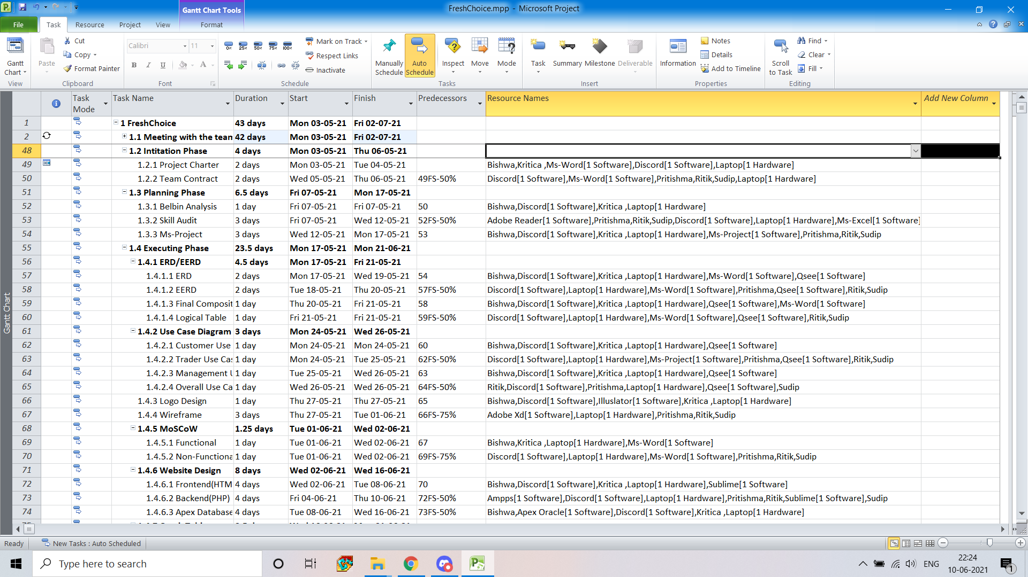

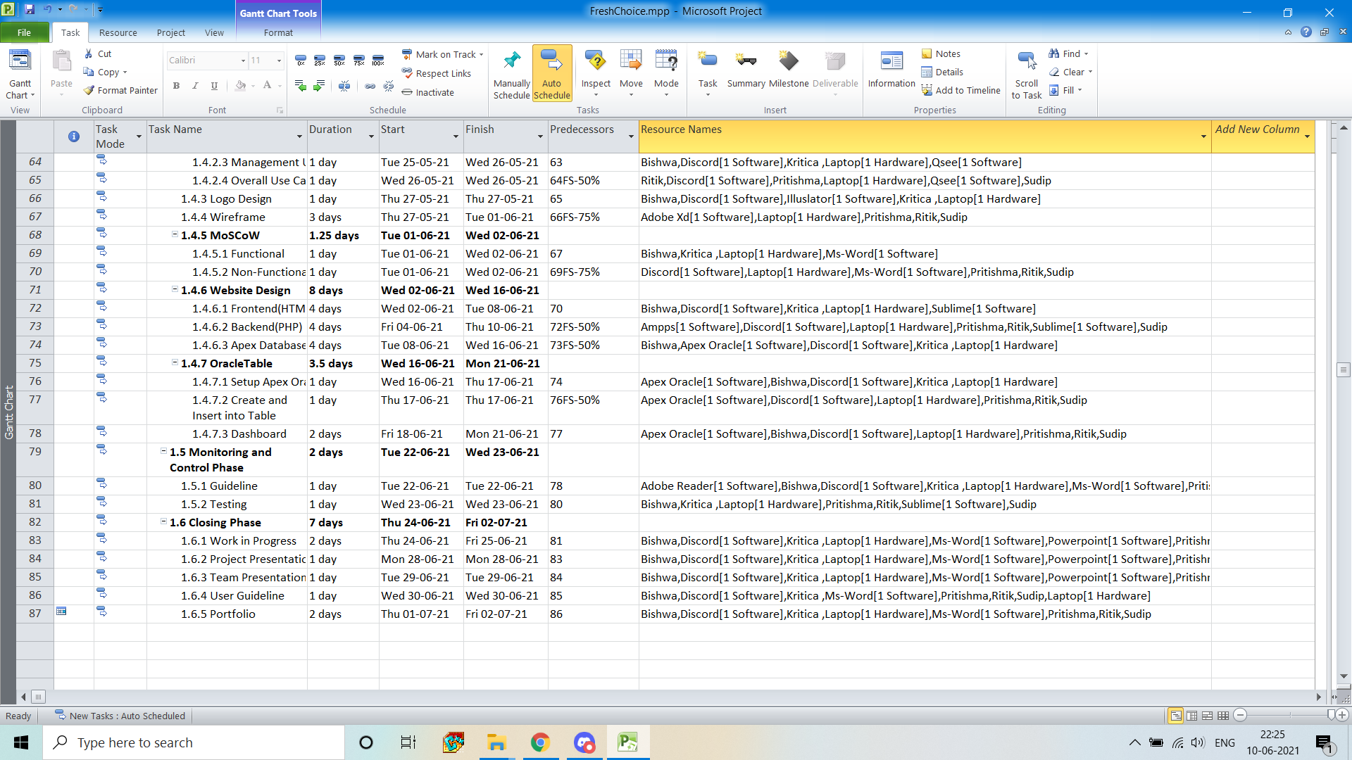

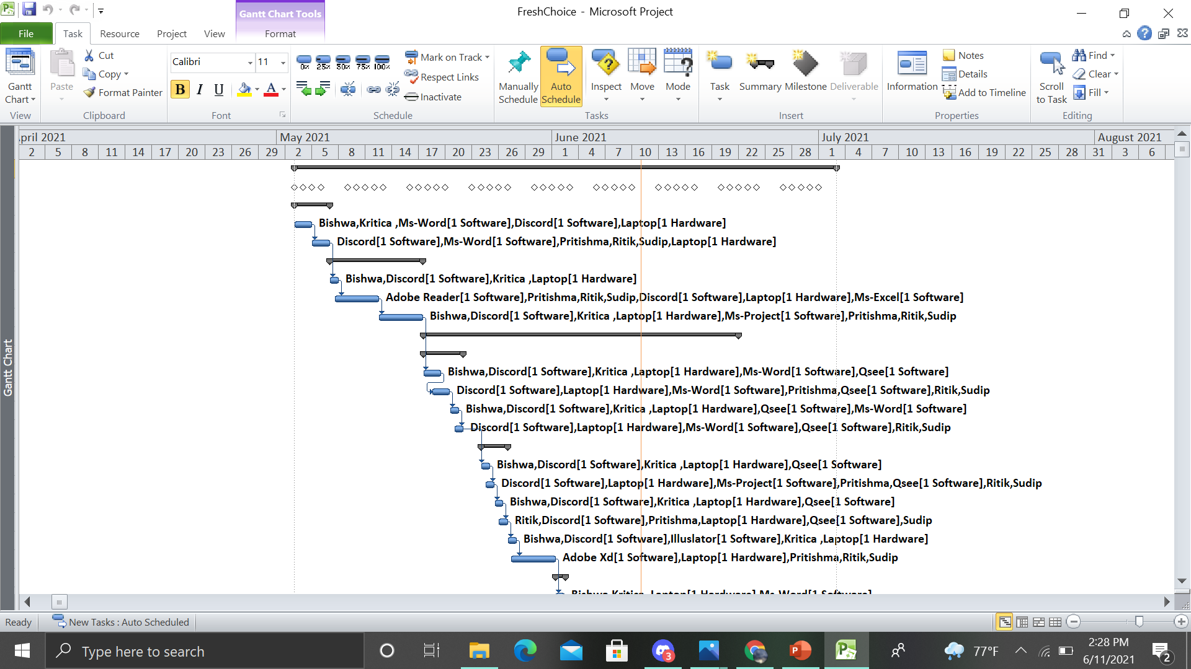

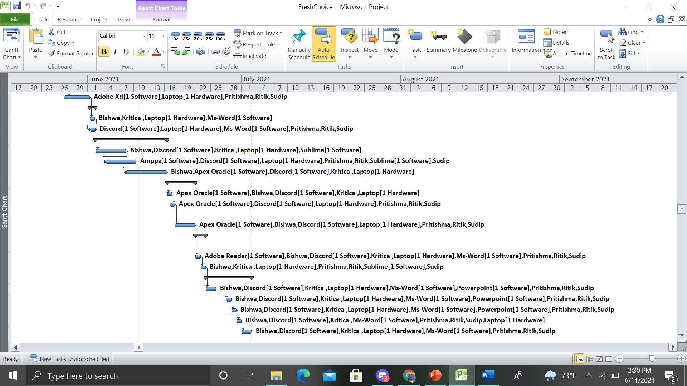

* **Timeline**

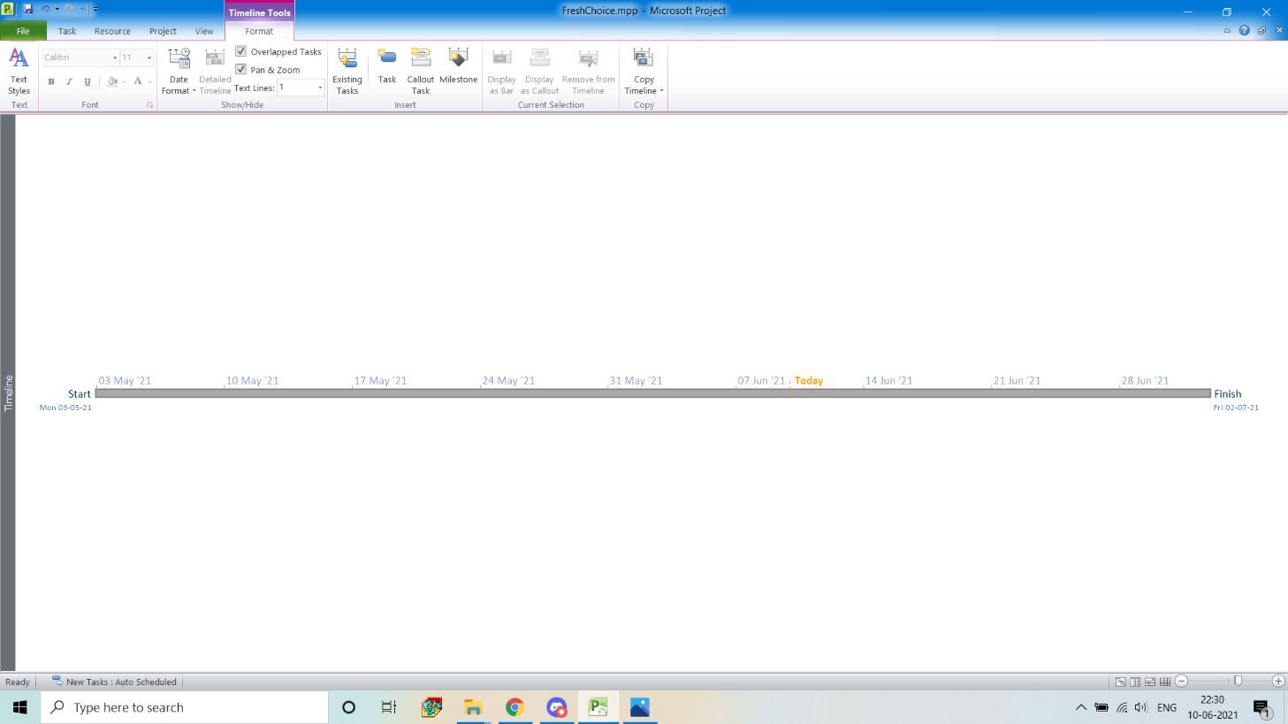

* **Calendar**

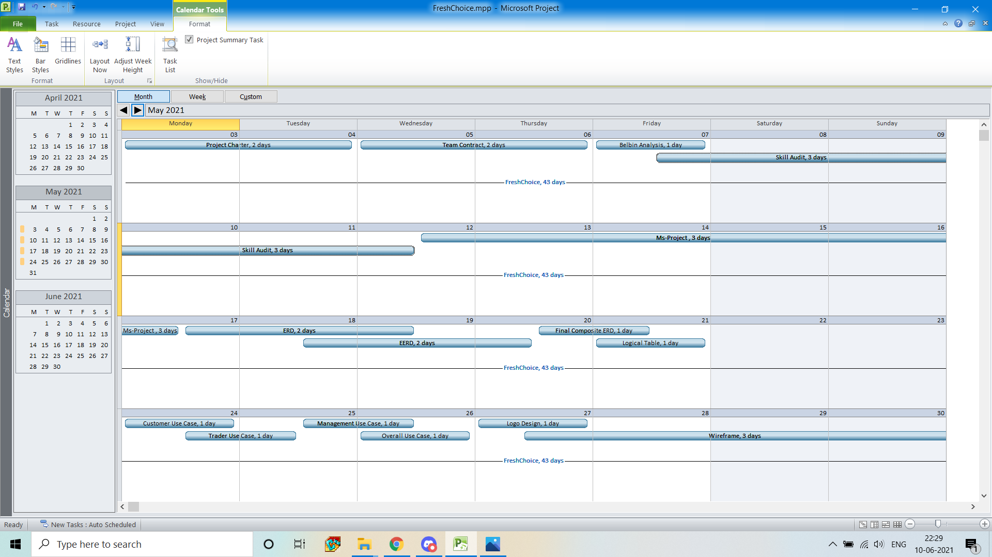

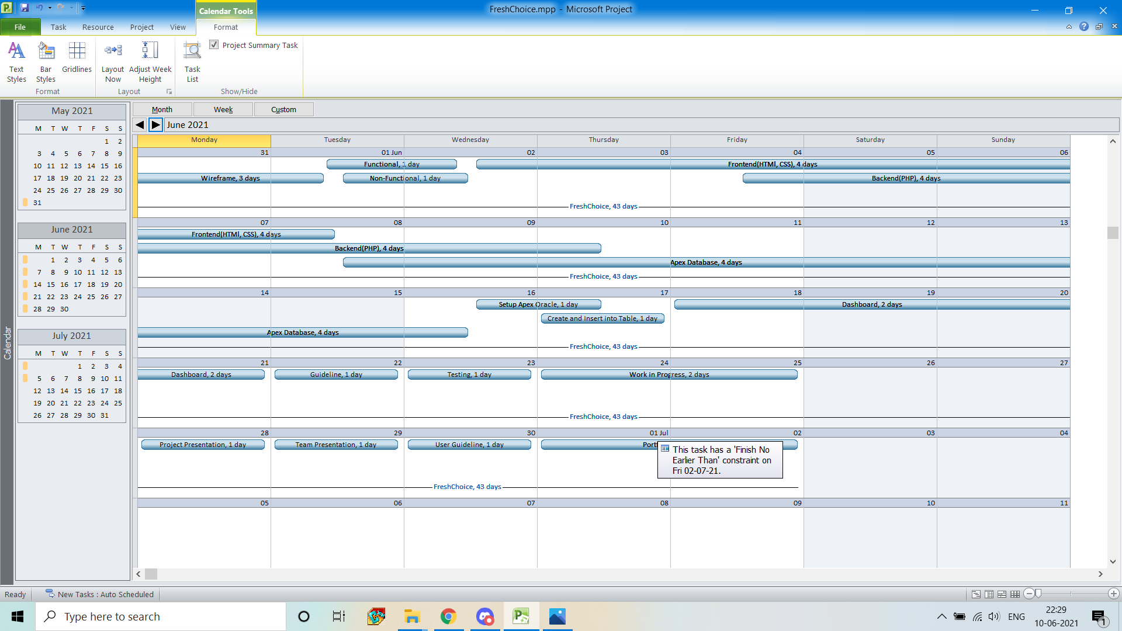

* **Resource Sheet**

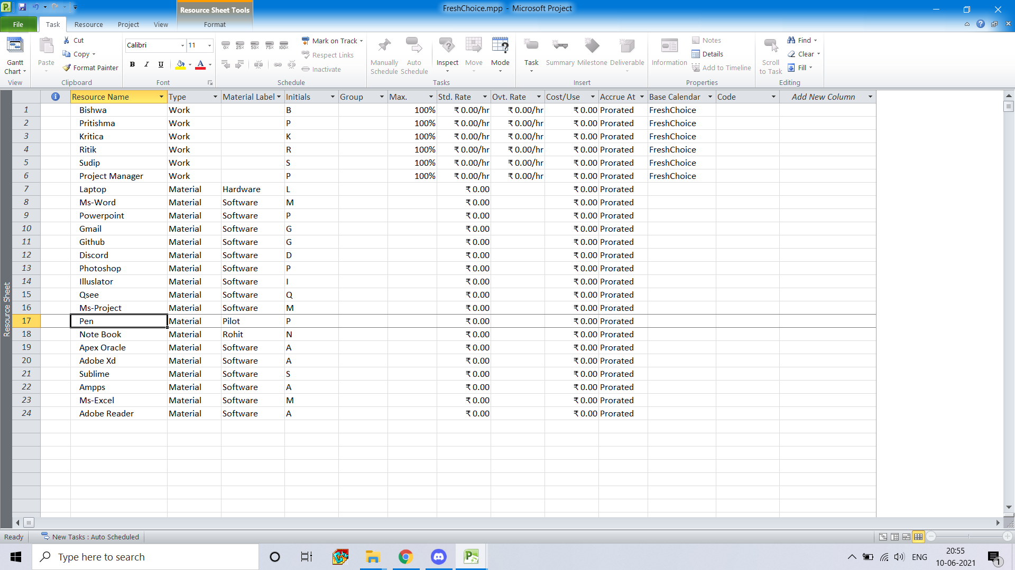

* **Change Working Time**

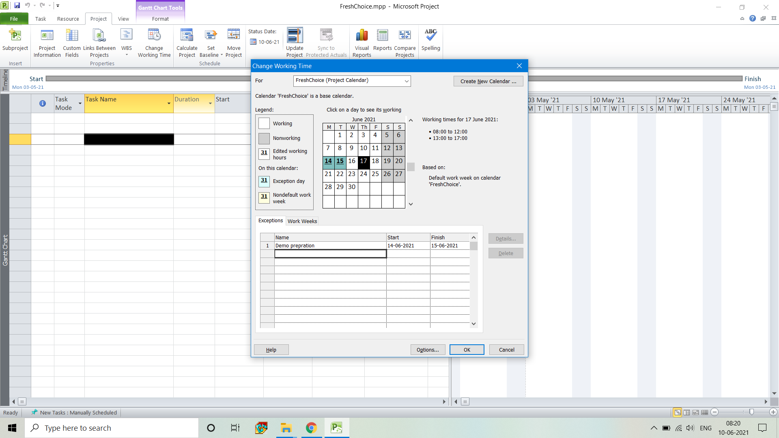

1. **Communication tools used**

* **Discord**

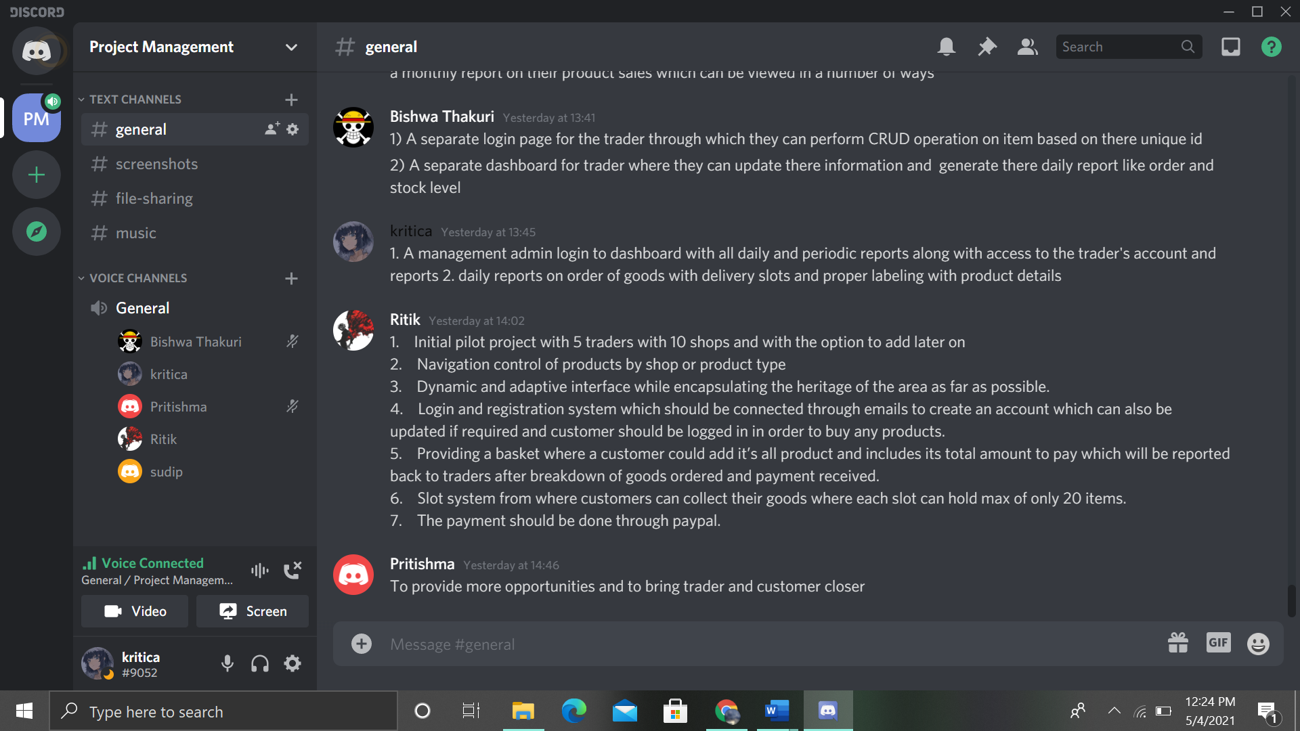

1. **Planning Phase**
2. **Belbin Analysis**

* **Team Belbin Analysis**

|  |  |  |
| --- | --- | --- |
| Version:1.0 **Team Belbin’s Analysis** Date reviewed: 05/02/2021 | | |
| Primary role | Kritica Shakya | Co-ordinator |
| Ritik Khadgi | Plant |
| Bishwa Thakuri | Specialist |
| Pritishma Pradhanang | Implementer |
| Sudip Shrestha | Team Worker |
| Secondary role | Kritica Shakya | Implementer |
| Ritik Khadgi | Resource Investigator |
| Bishwa Thakuri | Team Worker |
| Pritishma Pradhanang | Team Worker |
| Sudip Shrestha | Specialist |
| Least likely role | Kritica Shakya | Monitor evaluation |
| Ritik Khadgi | Implementer |
| Bishwa Thakuri | Shaper |
| Pritishma Pradhanang | Monitor evaluator |
| Sudip Shrestha | Implementer |

* **Individual Belbin Analysis**

|  |  |  |
| --- | --- | --- |
| Version:1.0  **Belbin’s Analysis** Date reviewed:05/02/2021 | | |
| Primary role | Kritica Shakya | Co-ordinator |
| Secondary role | Kritica Shakya | Implementer |
| Least likely role | Kritica Shakya | Monitor evaluator |

1. **Skills audit**

* **Team Skills audit**



* **Individual Skills Audit**



1. **Execution Phase**
2. **Entity Relationship Diagram**

* **EERD**



* **ERD**



* **Logical Table**

|  |  |
| --- | --- |
| **Entity** | **Attributes** |
| User | (*user_id*, firstname, lastname, user_role, phoneno, user_age, email, password, gender) |
| Shop | (*shop_id*, shop_type, *user_id*) |
| Product | (*product_id*, p_name, p_description, p_price, allergy_info, p_quantity, p_image, *shop_id, cart_no, discount_no*) |
| Order | (*order_no*, o_date, o_quantity, o_totalprice, *slot_no, cart_no*) |
| Payment | (*payment_no*, p_date, p_amount, *order_no, user_id*) |
| Report | (*report_no*, r_date, r_type, r_description, *user_id*) |
| Review | (*review_no*, rv_date, rv_description, *user_id, product_id*) |
| Discount | (*discount_no*, d_type, d_percentage, *user_id*) |
| Collection_slot | (*slot_no*, slot_date, slot_time, slot_days) |
| Cart | (*cart_no*, c_productquantity, *user_id*) |

* **Final Composite ERD**



1. **Use Case Diagram**

* **Overview Use Case Diagram**



* **Customer Use Case Diagram**



* **Trader Use Case Diagram**



* **Admin Use Case Diagram**



1. **MosCoW**

* **Functional Requirement**

1. Product

|  |  |  |
| --- | --- | --- |
| **Requirement Id** | **Description** | **MosCow** |
| **A1** | **All products should have details** |  |
| A1-1 | Products must have unique ID | M |
| A1-2 | Products must be associated with trader | M |
| A1-3 | Products must have name and price | M |
| A1-4 | Products must have description, quantity, min order, max order and stock availability | M |
| A1-5 | Products could have allergy information | C |
| A1-6 | Occasionally, products may have discounts | C |
| **A2** | **An interface to view products and shops** |  |
| A2-1 | Items must be displayed with image and short description | M |
| A2-2 | Every product must have an add to cart link | M |
| A2-3 | User must be able to display items by products or by shops | M |
| A2-4 | Users should be able to display items by category | S |
| A2-5 | User should be able to search for items by using text search | S |
| A2-6 | User could be able to give review on the products | C |

1. Customer

|  |  |  |
| --- | --- | --- |
| **Requirement Id** | **Description** | **MosCow** |
| **B1** | **Login and register by customer** |  |
| B1-1 | Customer must be able to login by username and password | M |
| B1-2 | New registration minimally requires name, password, email | M |
| B1-3 | Username verification and password strength verification | M |
| B1-4 | User should be able to update their account | S |
| B1-5 | Verification link to the customer | S |
| **B2** | **Customer should be able to view products** |  |
| B2-1 | Customer must be able to sort and search products | M |
| B2-2 | Customer must be able to view product details and reviews | M |
| B2-3 | Customer should be able to give reviews. | S |
| **B3** | **Customer cart and choice** |  |
| B3-1 | Customer must be able to add products in the cart | M |
| B3-2 | Customers will have maximum 20 orders limit | M |
| B3-3 | A customer must have a single basket that holds all goods and require single payment | M |
| B3-4 | Customer will be able to update and remove products in the cart | S |
| B3-5 | Customer could view the total product price | C |
| **B4** | **Payment and collection** |  |
| B4-1 | Customer must be able to select collection slot and time slot | M |
| B4-2 | Payment must be done by PayPal | M |
| B4-3 | Customer must login before placing any order | M |
| B4-4 | Customer collection slot must be at least 24 hours after placing the order. | M |

1. Trader

|  |  |  |
| --- | --- | --- |
| **Requirement Id** | **Description** | **MosCow** |
| **C1** | **Login and register by trader** |  |
| C1-1 | A trader must have different login | M |
| C1-2 | A trader inorder to register must minimally input trader details, trader’s shop type | M |
| C1-3 | Trader’s registration confirmation through email | M |
| C1-4 | Traders could be able to view and update their accounts | C |
| **C2** | **Shop of traders and their products** |  |
| C2-1 | Traders must have at least one shop each | M |
| C2-2 | Different trader product lines must not overlap | M |
| C2-3 | Traders should be able to add/ update/ delete product of their shops. | S |
| C2-4 | Traders could provide occasional discounts on the products | C |
| **C3** | **Payment of trader** |  |
| **C4** | **Reports** |  |
| C4-1 | Traders must be able to run reports daily on ordered goods. | M |
| C4-2 | Traders should be able to view weekly finance reports | S |
| C4-3 | Traders are provided with a monthly report on their product sales | S |

1. Management

|  |  |  |
| --- | --- | --- |
| **Requirement Id** | **Description** | **MosCow** |
| **D1** | **Login** |  |
| D1-1 | Management must have a separate login | M |
| D1-2 | Management must be able to look over customers account and traders account | M |
| D1-3 | The management can deactivate traders account | C |
| **D2** | **Dashboard and Supervision** |  |
| D2-1 | Management must be able to supervise products for any duplication | M |
| D2-2 | Management will be able to delete inappropriate reviews | S |
| **D3** | **Reports** |  |
| D3-1 | Management can view different reports to the traders | C |

* **Non-Functional Requirement**

|  |  |  |
| --- | --- | --- |
| **Requirement Id** | **description** | **MosCow** |
| **E1** | **The website will comply with the following nonfunctional requirements.** |  |
| E1-1 | The website must be responsive as it will be able to be viewed from desktop as well as other mobile devices | M |
| E1-2 | Information security | M |
| E1-3 | The website will have less loading time | S |
| E1-4 | Quality of website | S |
| E1-5 | Better user experience | S |
| E1-6 | No bug Weekly testing | S |
| E1-7 | Weekly testing | C |

1. **Logo design**



1. **Wireframe**

* **Website Homepage**

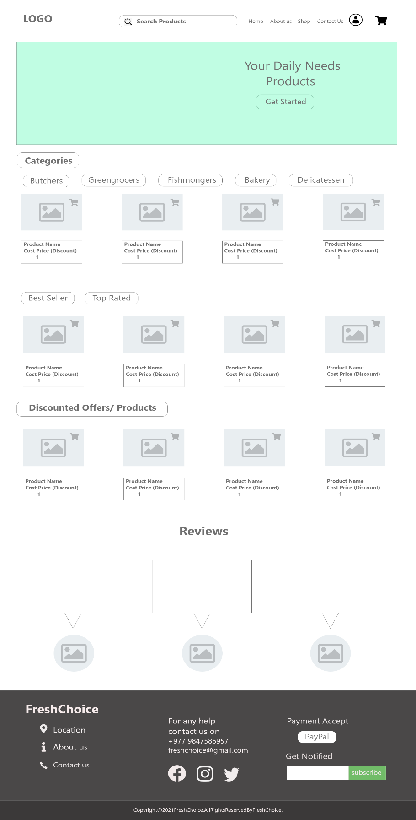

* **Website Aboutpage**

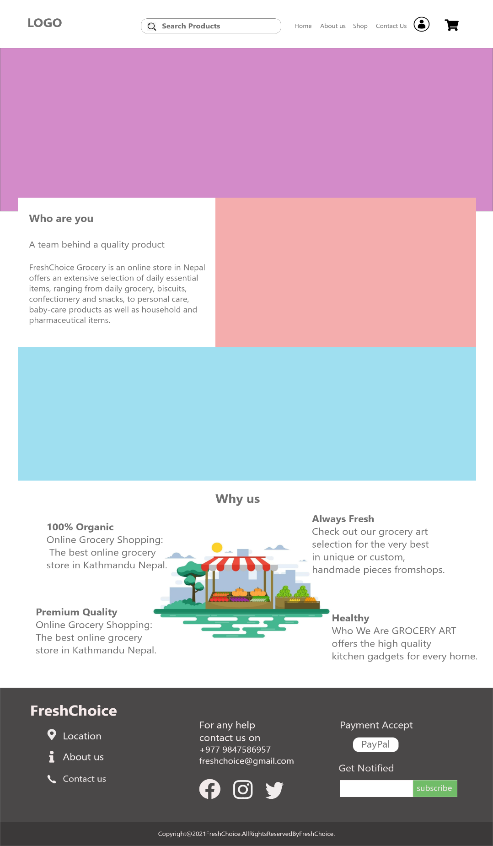

* **Website Contactpage**

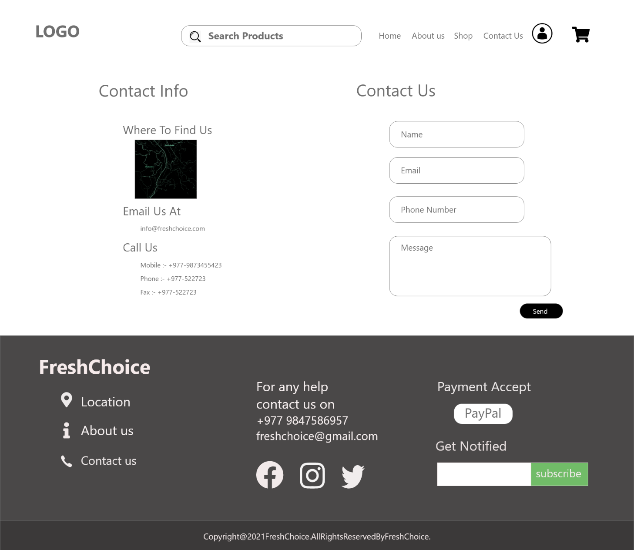

* **Admin CRUD**

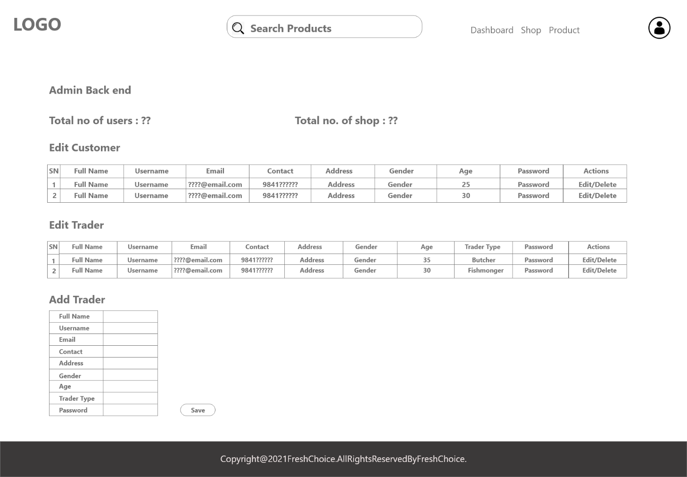

* **Trader CRUD**

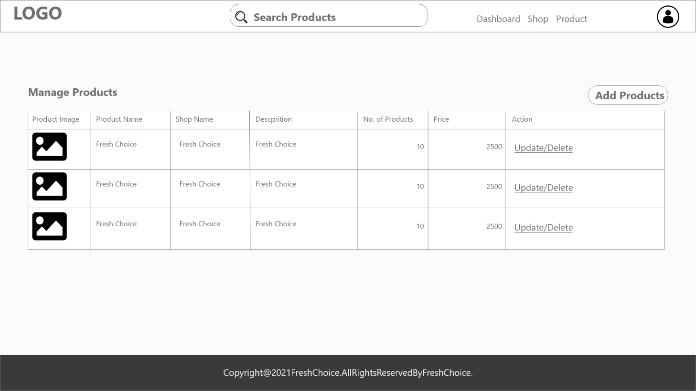

* **Cart**

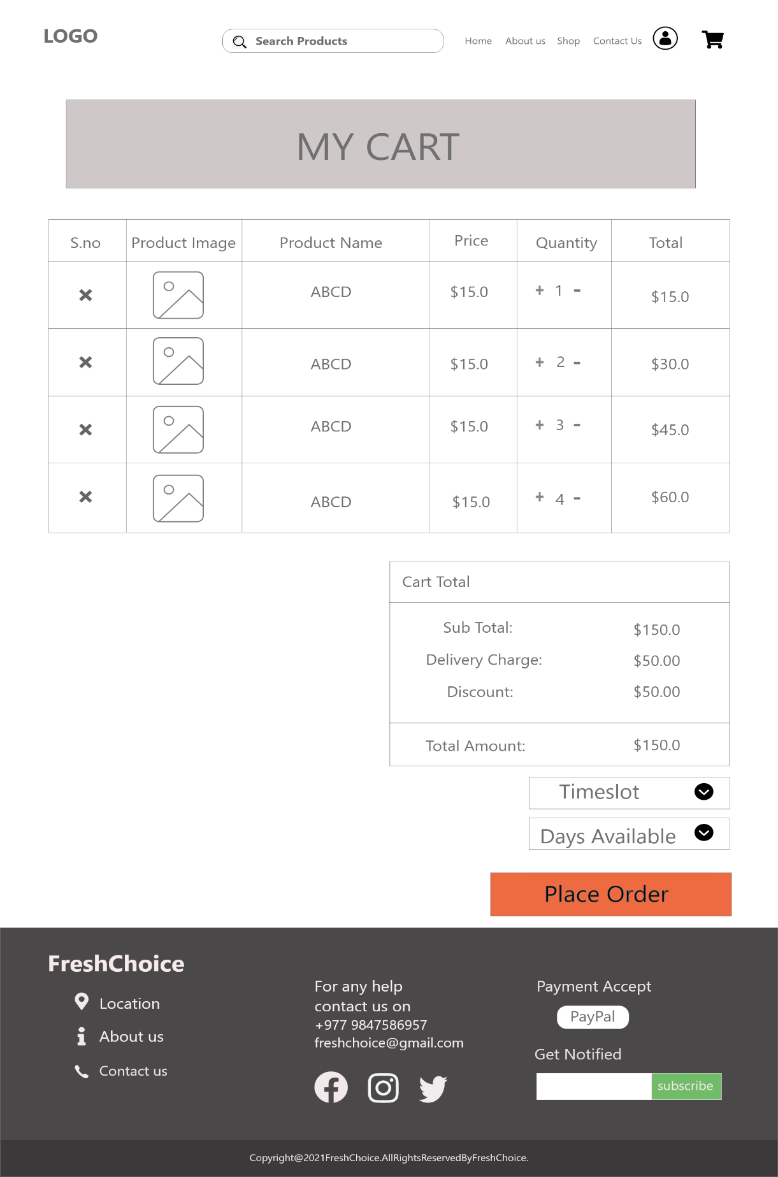

* **Customer Register**

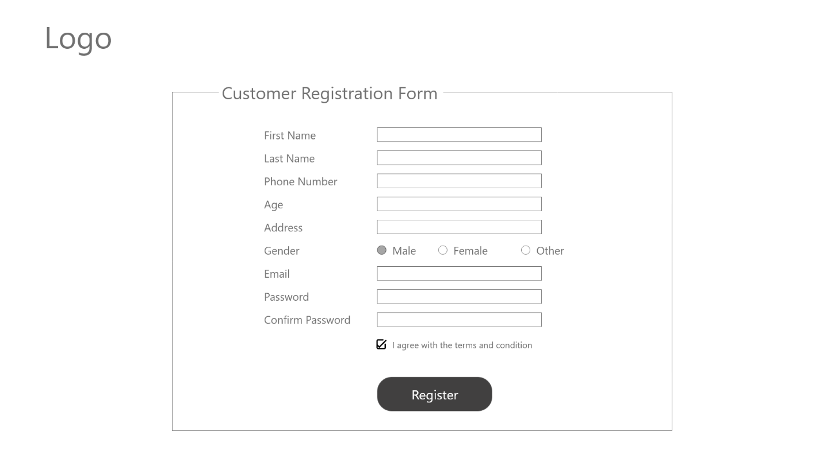

* **Trader Register**

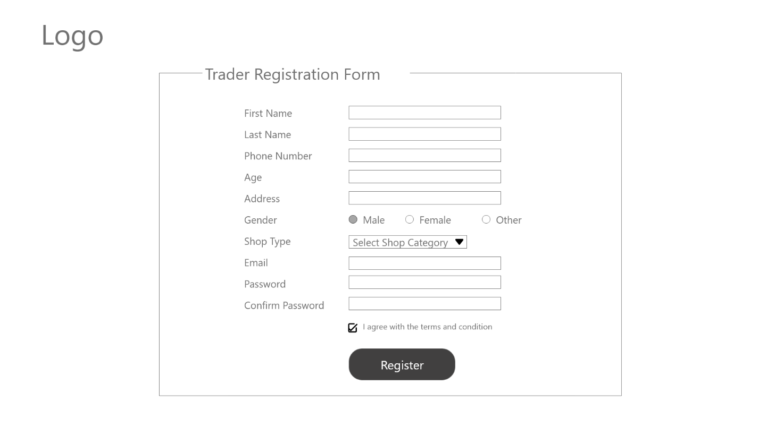

* **Customer Profile**

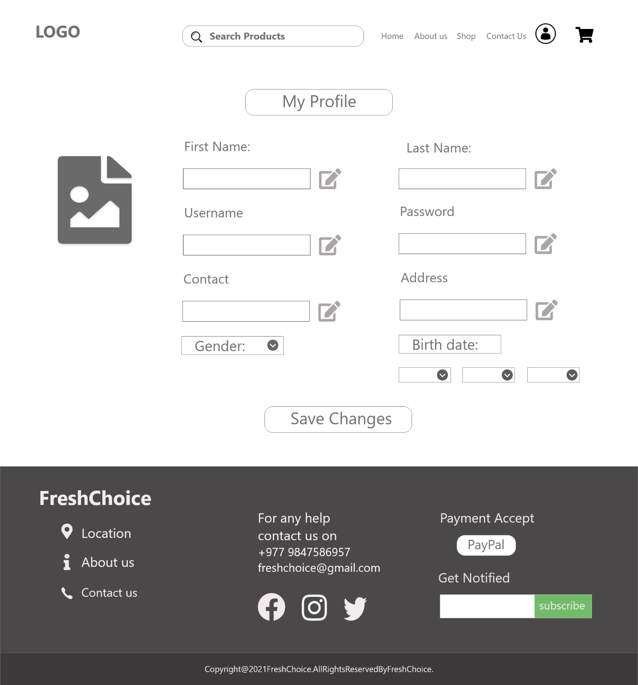

* **Dashboard**

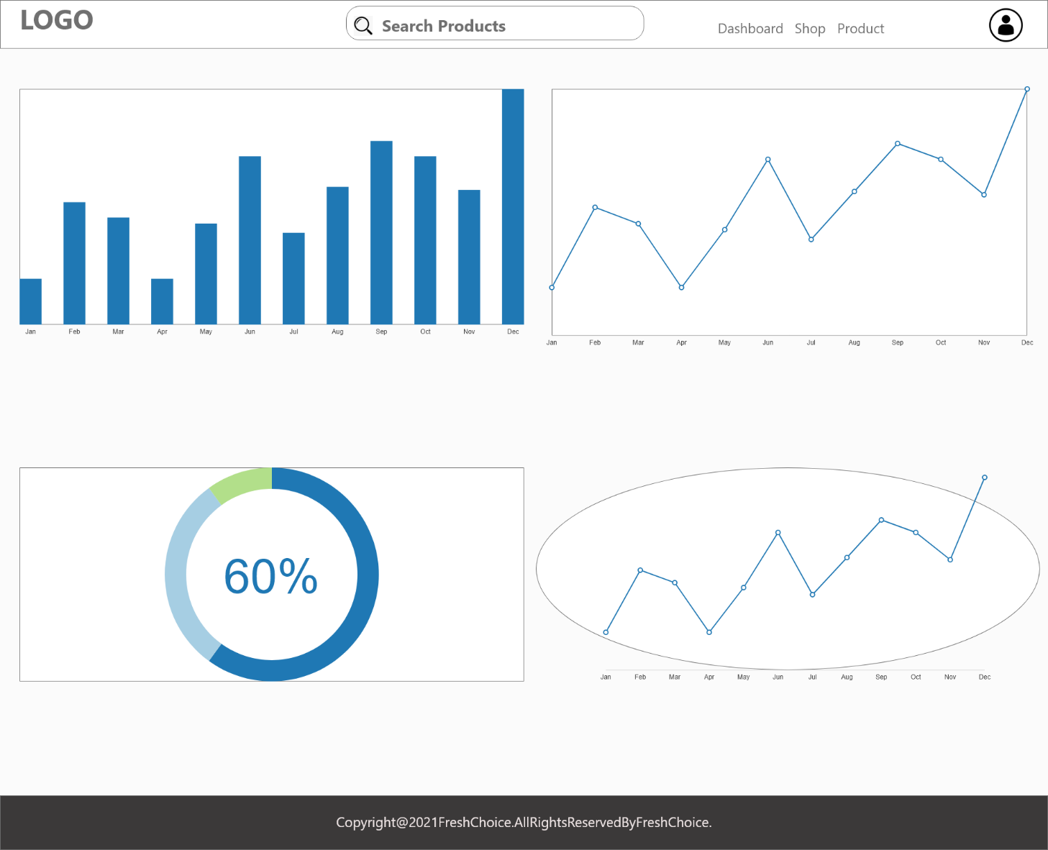

* **Invoice**

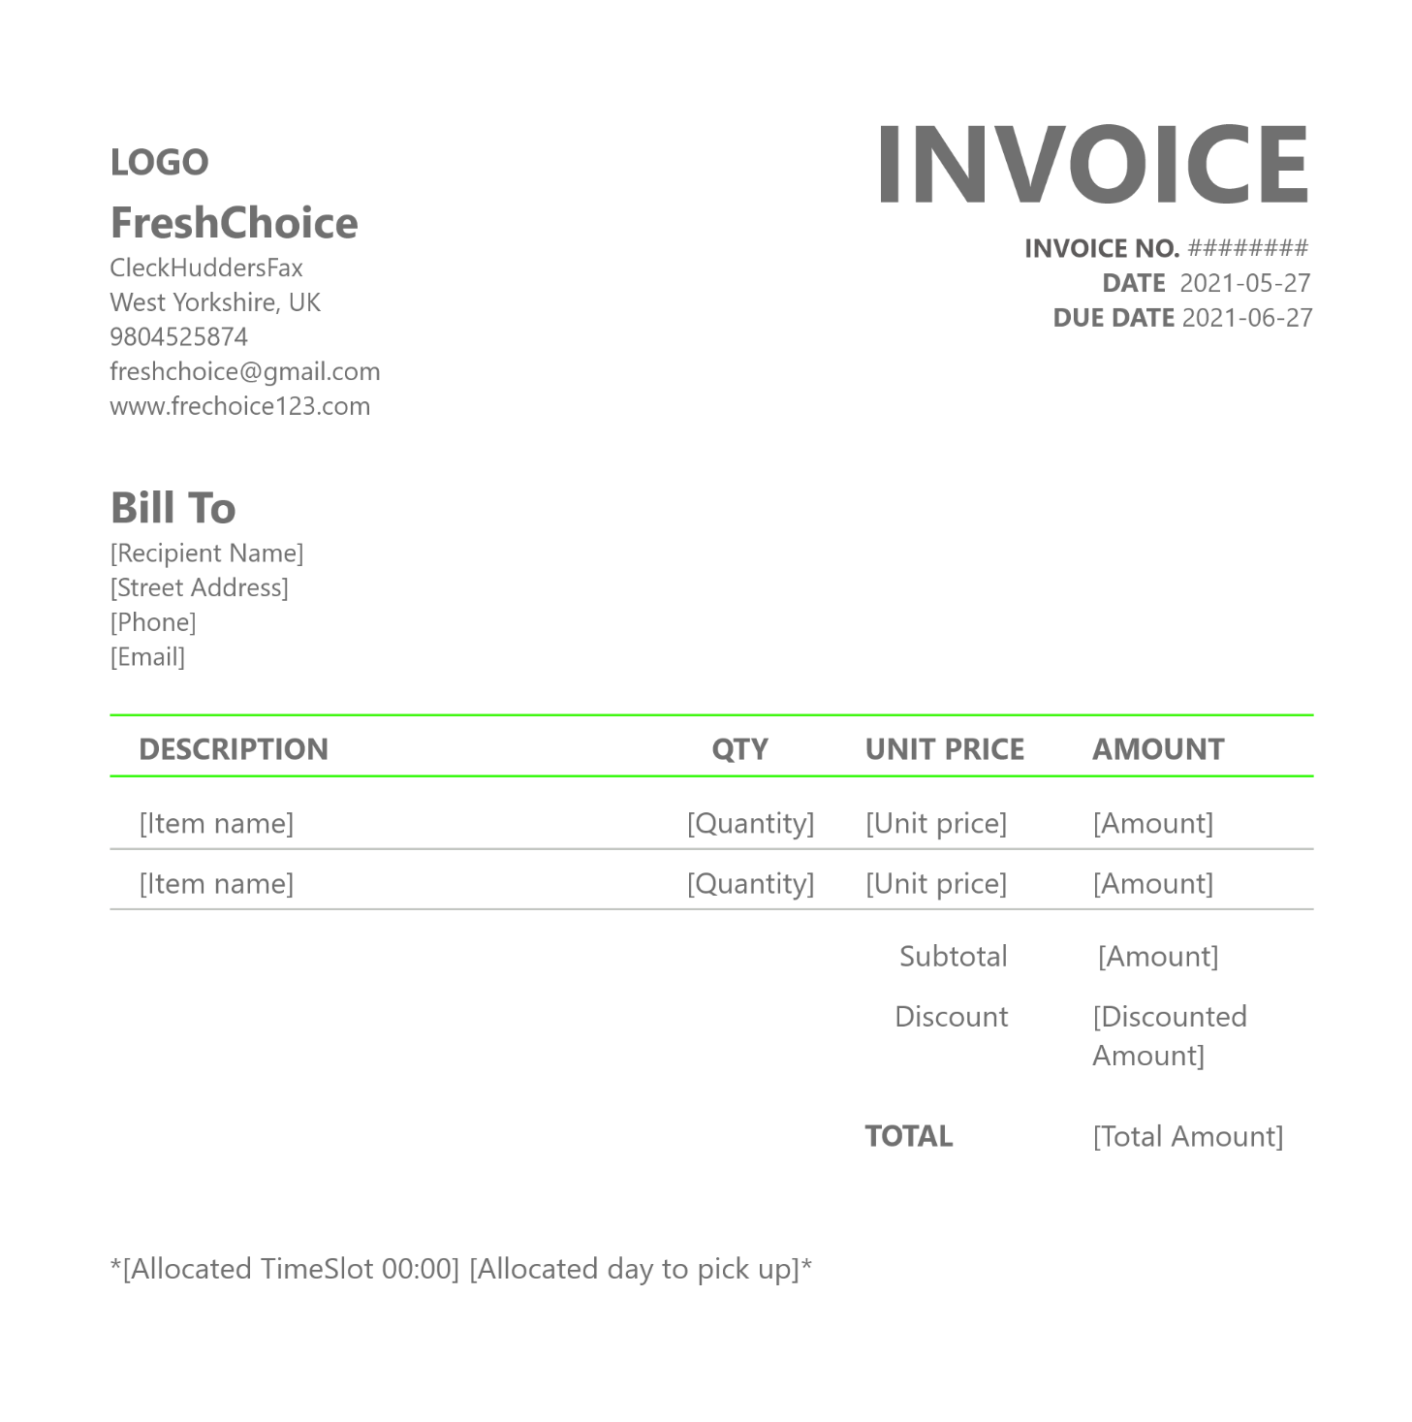

* **Login**



* **Product detail/Review**

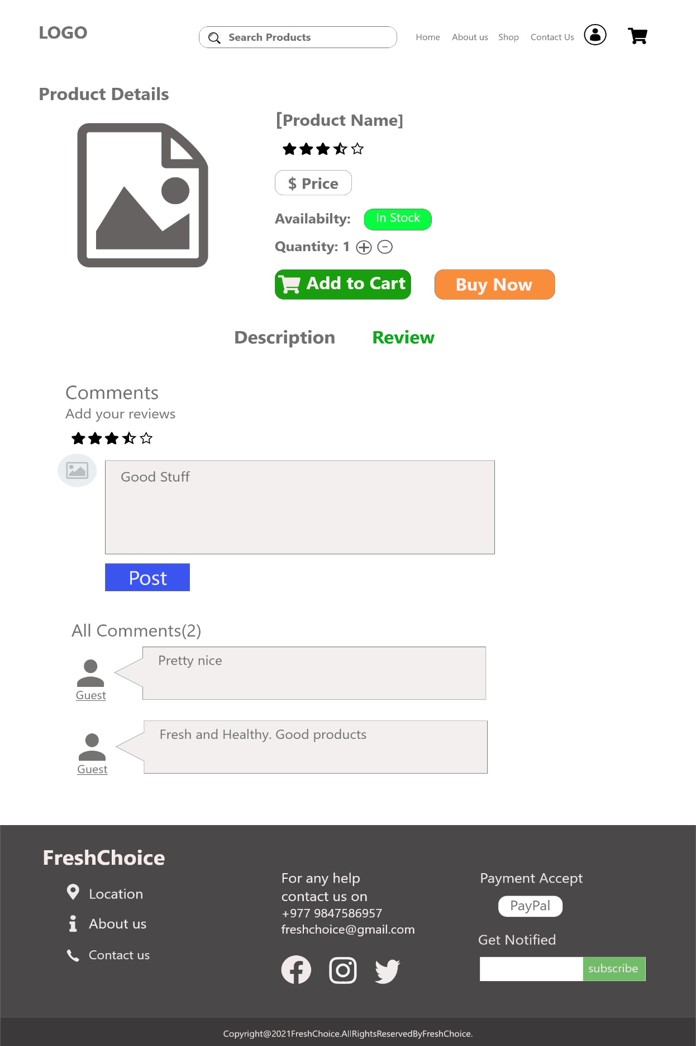

* **Shop**

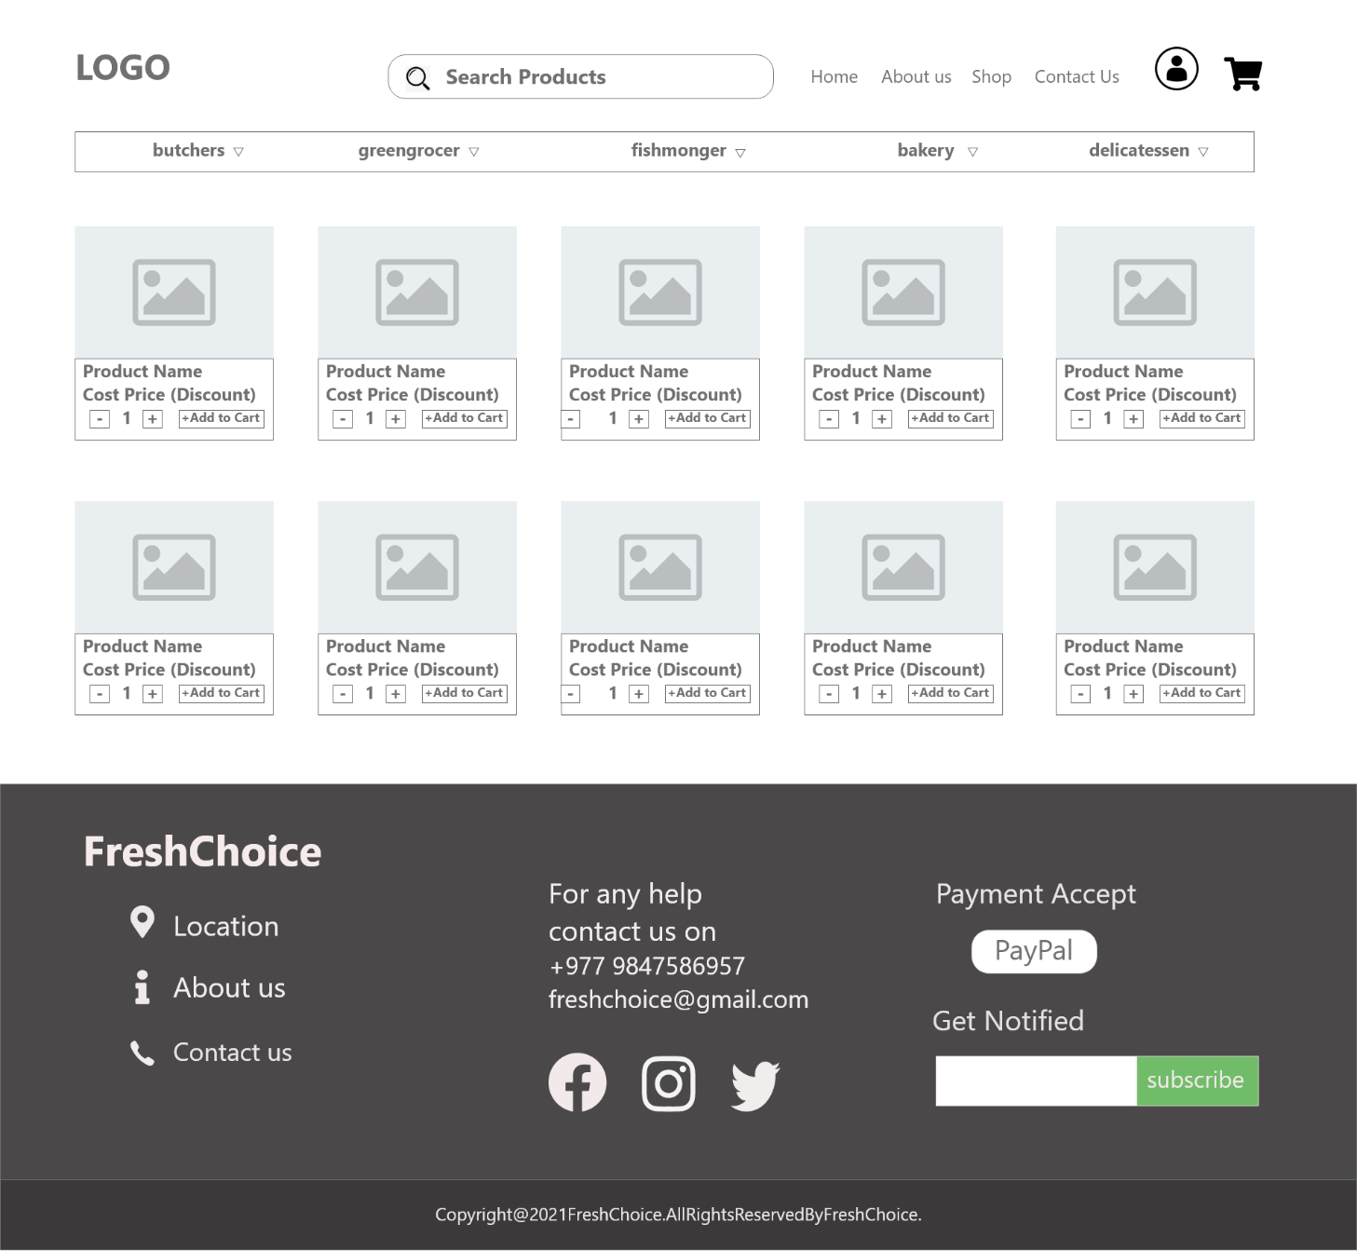

1. **Product Development**

* **About page**

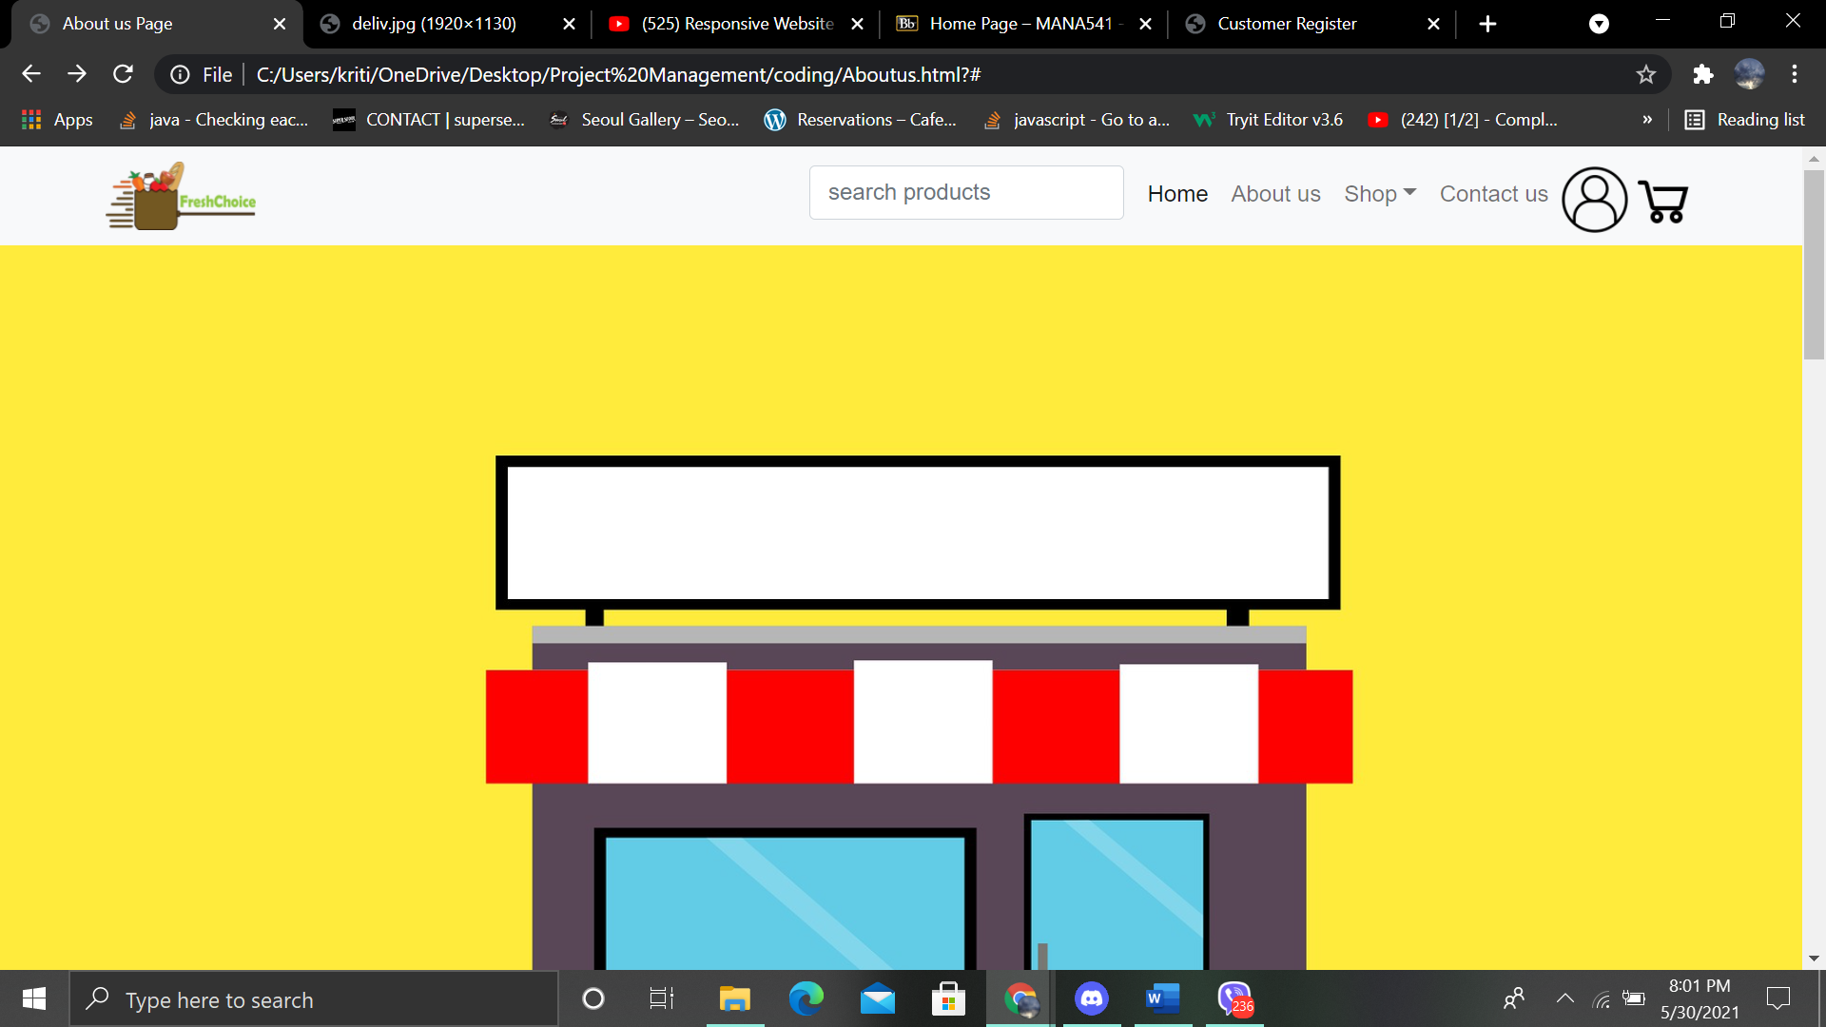

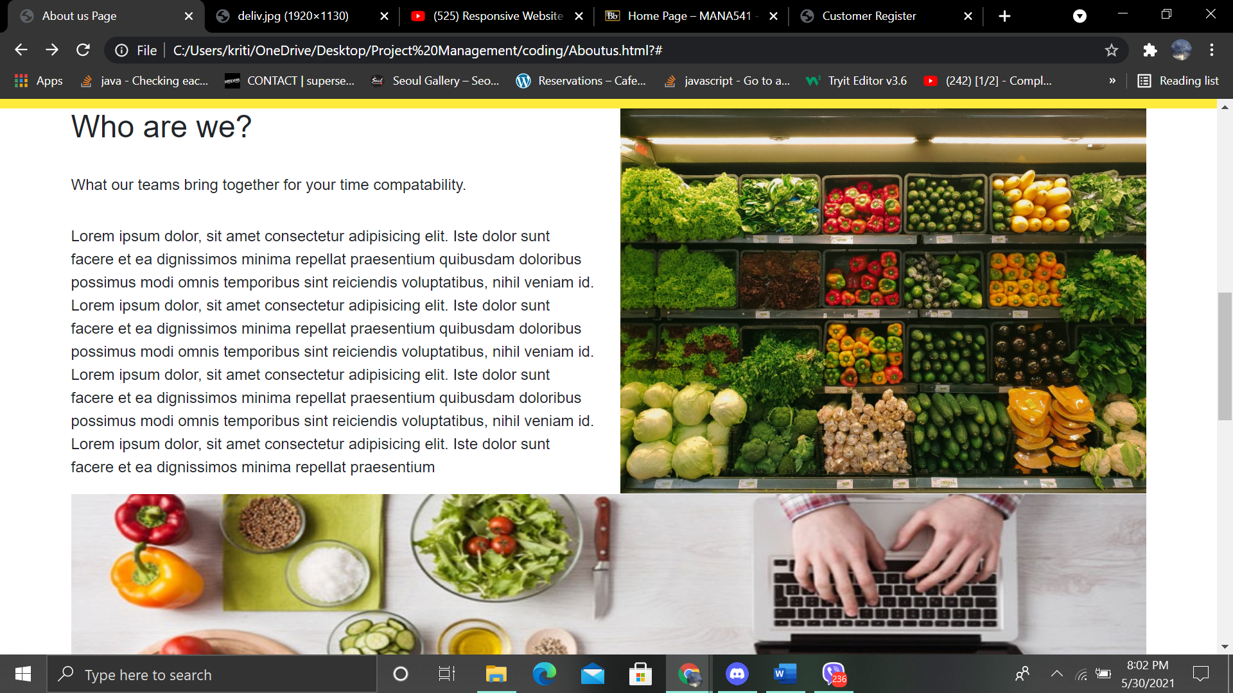



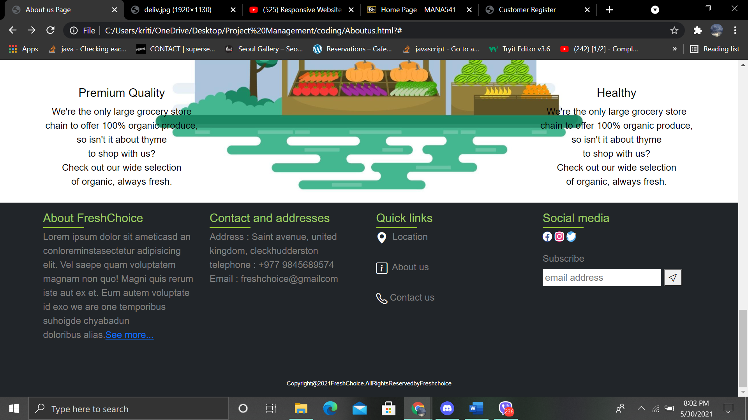

* **Website Contactpage**

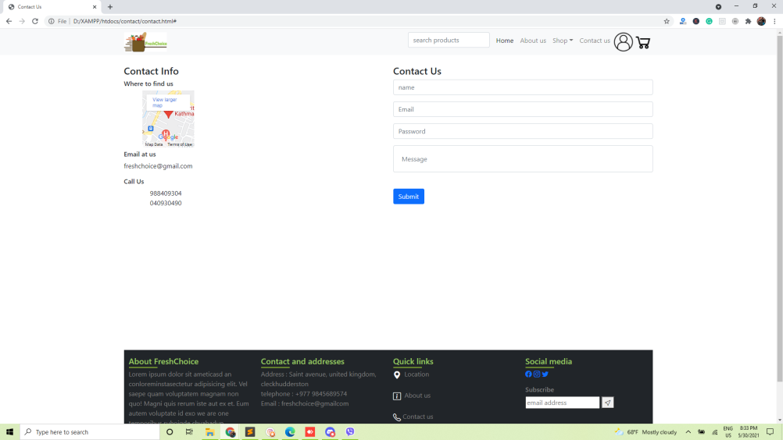

* **Customer Register**

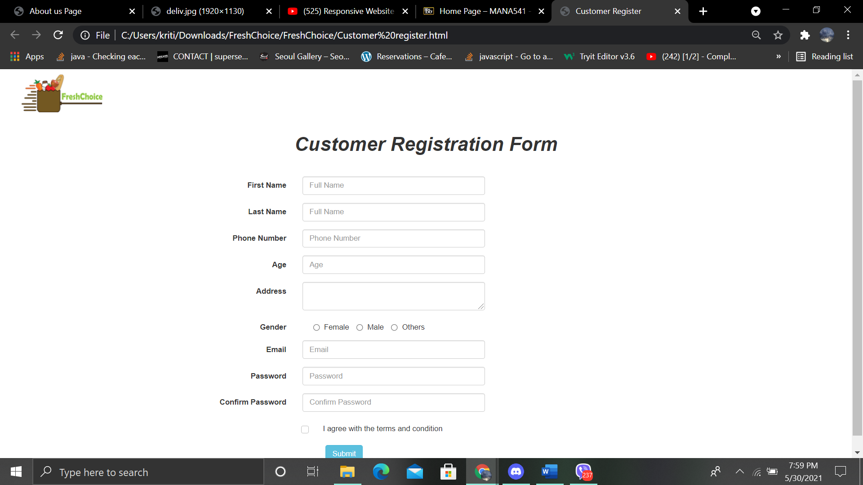

* **Trader Register**

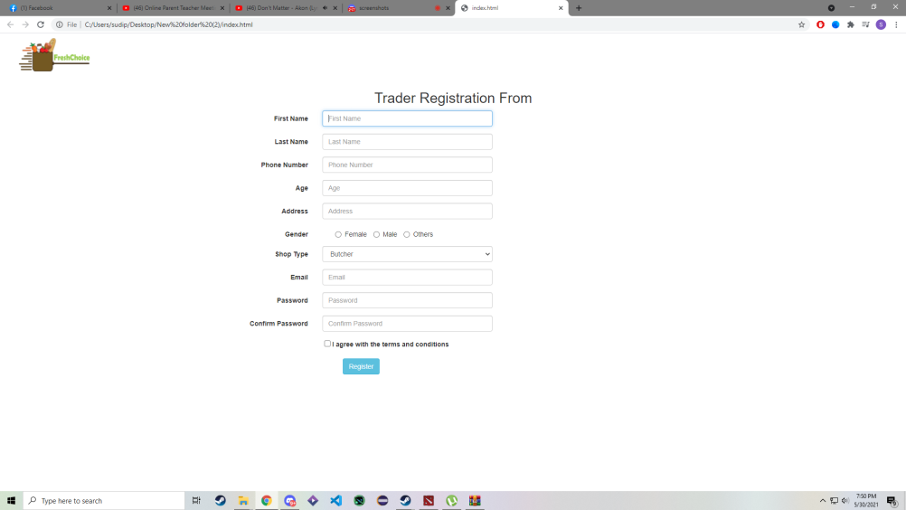

* **Login**

